* Dashboard
  + No labeling – don’t know what is what.
* Manage Sales
  + Add Sales *Rather than separated tabs, would like “product info , customer info and payment info” in one page/tab.*
    - Product Info
      * Cannot type in “search by item”
    - Customer Info
      * “Sales Man, Delivery by, Delivery Cost, Sales Date, Document”—not mandatory to insert for each transaction.
      * Why is document linked into delivery cost and reff no at the same time? (Usually reff_no comes after delivery process)
      * Create button does not work.
    - Payment Info
      * All bar area linked automatically each number entered.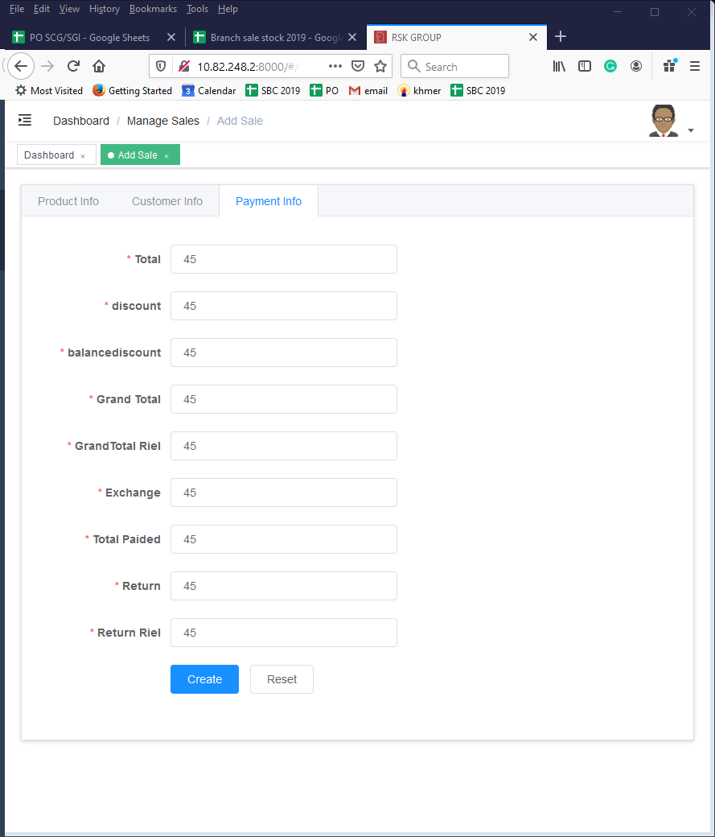
  + Sale List
    - * Large space for the list.
* Manage Payment
  + Add Payment
    - Customer name cannot search; button cannot use.
    - All bar are linked. Please fix.  
      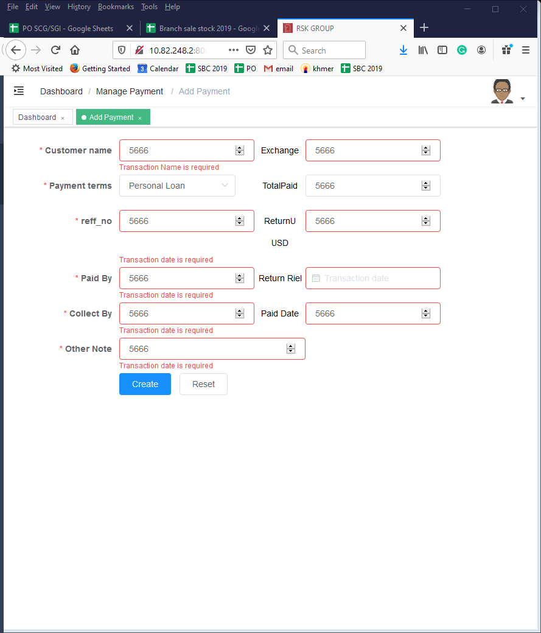
    - “Exchange” not necessary. “Return Riel” is marked as transaction date form. Pls fix.
  + Payment List
    - Move into report section instead.
* Mange stock
  + Stock Transaction
    - “Reference No.” bring to top.
  + Stock List
    - Stock list button link to project. Pls fix.
    - Stock list is separated by transaction and not by branch. Layout is confusing. What is the purpose?
* Manage delivery
  + Add Delivery Note
    - Blank page. Cannot review.
  + Delivery List
    - Some button error. Pls fix.
* Manage customer
  + Add Customer
    - Spelling mistakes.
    - Why need anniversary date?
  + Customer List
    - Cannot search by name. pls fix.
    - No credit value and or status bar.
      * example. Over limited credit or Almost at limited credit.
    - No have option to see invoice by customers or invoice details by customer.
* Manage warehouse
  + Add Warehouse
* Manage project
  + Project Enquiry
    - Didn’t include sales agent or project contractor.
* Manage reports
  + Sales report.
    - No have daily sales report? Please add
    - No need to have transaction name or product name. If have, have them as separated option and not all bar should be mandatory.
    - No need to have transaction amount.
  + Stock Report
    - Should separate stock in and stock out by branch.
    - No need transaction name, transaction amount and product name.
    - Should have transaction start date and end date.
  + Customer report.
    - No need transaction name, product name and transaction mode and transaction amount.
* Configuration
  + “Transaction amount”, What for?

Overall comment:

* How to search for specific invoice?
* Manage stock and manage warehouse should be in the same category.
* Need to name each tab more clearly, for example the report section. What report is it? Customer list, customer list overall, or customer credit or customer invoice detail? Please name clearer.
* Need more report list.
* A lot of button still isn’t working.
* Still cannot product invoice sample. The sale section flow is still very confusing.